Project 5

CIS424



Peter Parianos

Grail login id: peparian

**Part 1: deviceQuery**

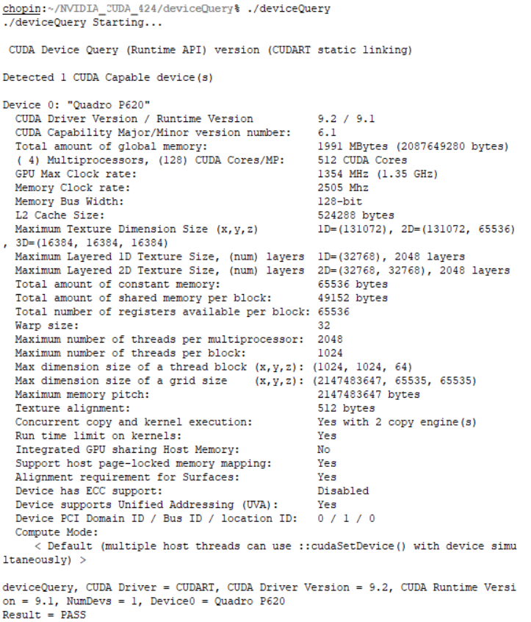

The GPU clock rate is: 1.35 GHz

The total number of CUDA cores is 512

**Part 2: Euclidean Distance**

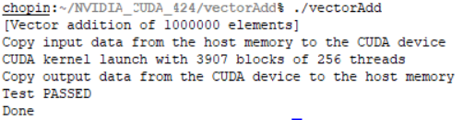

I needed to make modification to both the calculations for the CPU and the GPU when we verify that the result vector is correct.

**Part 3: Performance Comparison of Matrix**

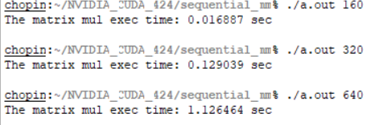

matrixMul:

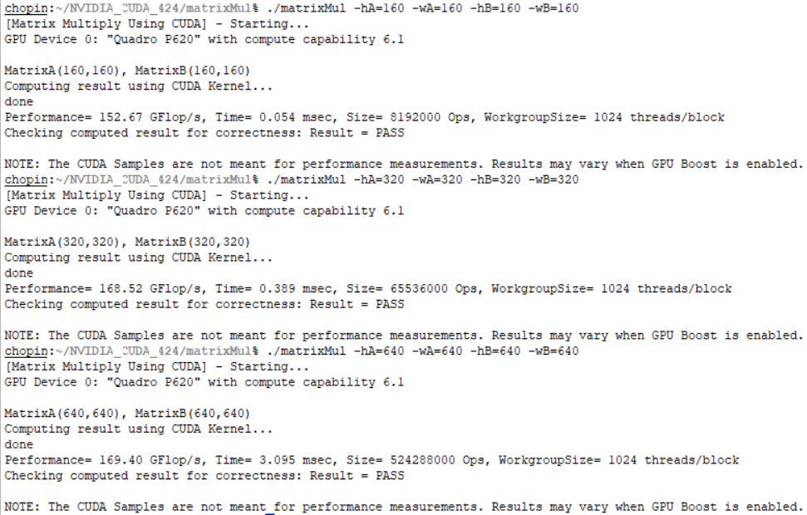

Speedup = CPUtime/ GPUtime

For n = 160: 0.016887sec / (0.054msec/1000)= 312.537037 times faster

For n = 320: 0.129039 sec / (0.389msec/1000) = 331.719794 times faster

For n = 640: 1.126464 sec / (3.095msc/1000) = 363.962520 times faster